**User Manual of Pharmacy Chatbot**

**Libraries Requirements**

-nltk

-numpy

-tkinter

To run the training phase, other two downloads can be done through implement ***train_chatbot.py****.*

**Run the GUI**

After download the file, unzip it and implement the ***chatgui.py*** on your terminal or any python idle. The output will show as below:

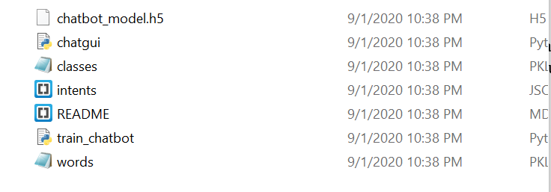

Figure 1: Contents of the ZIP file



Figure 2: Command to run the chatgui.py file

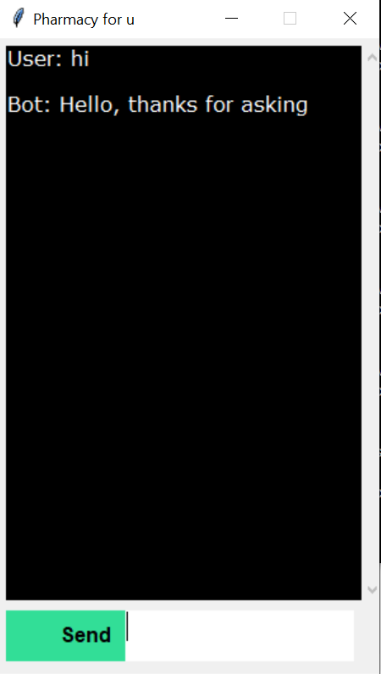

Figure 3: Chatbot interface

**Chat with the pharmacy chatbot**

After ran the chatgui.py file successfully, you may key in some words and click the send button to make a simple conservation with it. The response will base on the intents.json file. Below is the sample of chat:

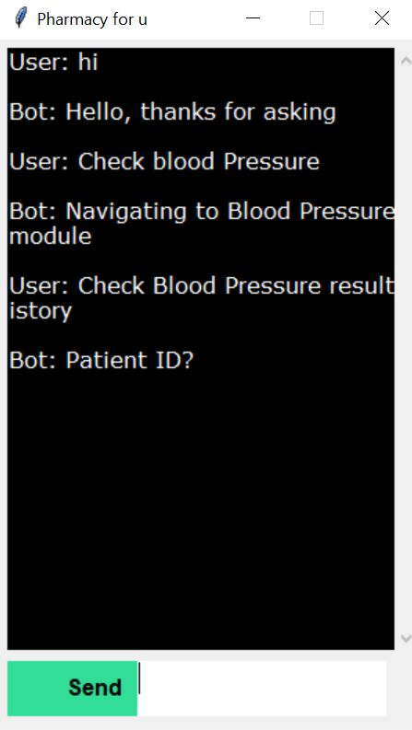

Figure 3: Chat sample